**Year 10 Rapid Reactions Quiz 1 Revision**

1. Complete the terms for each definition below:

|  |  |
| --- | --- |
| Term | Definition |
|  | Number of protons in the nucleus of an atom |
|  | Number of protons and neutrons in the nucleus of an atom |
|  | Number of electrons in the outside shell of an atom |
|  | Vertical column in the periodic table |

1. Label the atom below and complete the table.

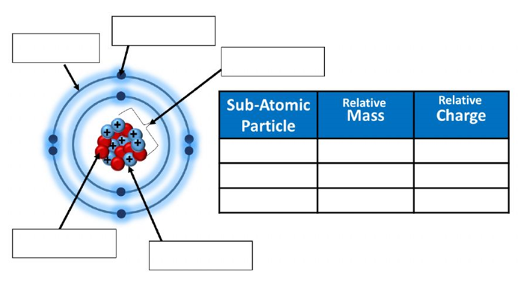

1. Complete the table below

|  |  |  |  |  |  |
| --- | --- | --- | --- | --- | --- |
| **Atom** | **Name of Element** | **Atomic Number** | **Mass Number** | **Number of Electrons in Neutral Atom** | **Number of Neutrons** |
| $$\begin{matrix}11 \\ 23\end{matrix} Na$$ |  |  |  |  |  |
|  | Chlorine |  | 35 |  |  |
| $$\begin{matrix}13 \\ 27\end{matrix} Al$$ |  |  |  |  |  |
|  |  |  |  | 9 | 10 |
|  | Bromine |  |  | 35 | 45 |

1. Complete the table below

|  |  |  |  |
| --- | --- | --- | --- |
| **Symbol** | **Number of Electrons** | **Electron Configuration** | **Electron Configuration diagram** |
| F | 9 | 2,7 |  |
| P |  |  |  |
| Si |  |  |  |
| Na+ | 10 |  |  |
| Ca2+ |  |  |  |
| Cl- |  |  |  |

1. Explain the difference between a **period** and a **group** in the Periodic Table. What do each of these tell us about the properties of elements?
2. A student conducted an experiment and made the following observations:

* Potassium is more reactive than sodium
* Sodium is more reactive than aluminium
* Fluorine is more reactive than bromine

**Explain** these observations using the diagram of the periodic table below.

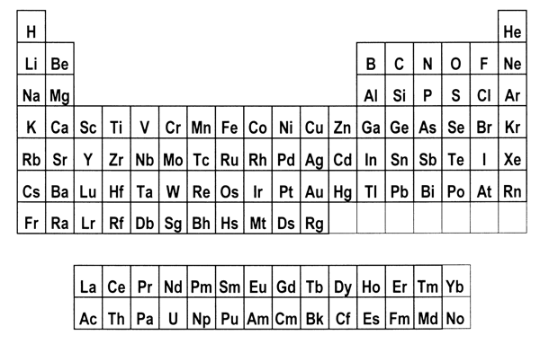

1. Complete the following table below for each bonding type by sorting the given terms into the correct row.

|  |  |  |  |  |
| --- | --- | --- | --- | --- |
| Left, Centre and Right | Soft if solid | Shared electron pairs | High for solids | Low to high |
| Left and Centre | Brittle and hard | Oppositely charged ions | Not as solids but does when molten | High |
| Right | Malleable | Delocalised electrons and positive ions | Not as solids or liquids | Usually low |

|  |  |  |  |  |  |
| --- | --- | --- | --- | --- | --- |
| Type of Bonding | Periodic Table location | Structure | Bond contains: | Conductivity | Melting Point |
| Metallic |  |  |  |  |  |
| Ionic |  |  |  |  |  |

1. In terms of bonding, explain why copper can be stretched into wires but copper chloride cannot.
2. Circle the correct answer for each statement
   1. Elements are arranged on the periodic table according to their:
      1. Mass
      2. Atomic number
      3. Number of electrons
   2. These are the symbols for the elements oxygen and sodium
      1. O and SO
      2. O and Na
      3. Ox and Na
   3. Group 1 elements have this property
      1. React with water
      2. Are metals
      3. Have a single electron in their outer shell
   4. The chemical properties of an element are mainly influenced by
      1. Number of electrons
      2. Number of neutrons
      3. Number of protons